
Statewide Automated Child Welfare Information System
(SACWIS)

Phase IIA Training
HANDOUTS

- SACWIS Process Flowchart
- SACWIS Information Relationships
- Tips for Getting Started After SACWIS Training
- SACWIS/CYCIS Integration Help Sheet
- Summary of New Releases

Tips for Getting Started After SACWIS Training

Table of Contents

Topic | Page
Checking Your Desktop | 2
Case Maintenance | 2
Changes Support Policy | 4
Assessments | 4
- Safety Assessment | 4
- Risk Assessment | 6
- Integrated Assessment | 7
- Service Plan | 9
Case Notes and Contact Notes | 11
Quick Reference for Entering Information in SACWIS | 12

Checking Your Desktop
The first thing you should do when you return to your office from SACWIS training is check your Desktop. To do this, Single Click on the SACWIS Icon to bring you to your Desktop. (Once in SACWIS, you always single click – double clicking will freeze the application.) Now, do the following:
- Make sure your name is correct.

- Make sure your current role is correct. In most cases, your role will be Child Welfare Specialist or Child Welfare Supervisor.

- Click on the hyperlink for Click here to change your role.

- Make sure that the information provided is accurate for your role, your team designation, and your immediate supervisor.

- You probably will have a Conversion role that was given when the system was switched to SACWIS. This role should be end-dated by your supervisor.

- Go to Cases on your Desktop and make sure all of your cases are listed.

- Remember that in SACWIS there are family cases and separate child cases if the child is in placement.

- Report missing cases to your supervisor.

Case Maintenance
Some information that you enter in SACWIS will appear on multiple documents in SACWIS, including the Assessments and Service Plans. Taking time to ensure correct information is entered in Case Maintenance and in Person Management will save you time in the future.

You access the Case Maintenance Screen of a case by expanding the Cases arrowhead by selecting the case by clicking on the Case Name hyperlink. For example: (Smith, Joanne). Once in Case Maintenance, make sure the information that is provided about your case is correct.

- Make sure the CYCIS Case ID and Family Cluster ID are correct. If not, report this to your supervisor. This is very important. SACWIS is integrated with CYCIS. If CYCIS numbers are not showing, then you have a case that is opened in SACWIS only. If so, notify your supervisor, and, call the Help Desk.

- Make sure all of your case members are included. If they are not, you will need to add them to the case. This must be done prior to starting any Assessments.

- Click on the hyperlink for each case member to make sure the information on the Person Management Screen is correct.

- Make necessary changes to name spellings, birth dates, Social Security numbers, etc. Do not make any changes unless you have a source document confirming the information.

- Refer to SACWIS / CYCIS Integration help sheet to report changes for updating CYCIS.

- Make sure that each person in the case has a CYCIS Number (upper left-hand corner) in Person Management.

- Each Person Management Screen has a hyperlink (upper right-hand corner) to that person’s Health Screen. Put in the required information in the Health Screens before you complete an Integrated Assessment.

- Click on the Contact Info Tab to ensure case member phone numbers and addresses are correct.

- A primary address must be selected for each case member. This address should reflect the case member’s primary address. If a primary address is not selected for each member, it will prevent you from making any changes on the Basic Tab of the Case Maintenance screen.

- End-date duplicate addresses and old addresses.

- When you enter addresses, use single character abbreviations for directions (e.g., N, S, E, W). Use two-character abbreviations for streets (e.g., Rd, St, Av). Exceptions to this are Pkwy for Parkway, Blvd for Boulevard, and Hwy for Highway.

- Do not type periods after abbreviations (e.g., Rd.).

- The SACWIS field Street 1 should only include the physical address of the building / residence (e.g., 101 N Main St).

- Use Street 2 to enter the apartment number, floor number, or name of institution (e.g., Friedlander Correctional Institute).

- Save your work.

- Click Cancel to return to the Case Maintenance screen. Set the Household status (Yes or No) for each case; also select the Head of Household. Then Save your work.

- Review and update the Relationship Matrix. These data will be entered automatically into the Integrated Assessment.

Changes Support Policy
SACWIS enforces current DCFS policy. While many things will stay the same when you begin using SACWIS to document your work with DCFS cases, there are some differences.

For example:

- Risk Assessment has been added.

  - The Risk Assessment has to be completed before you can complete an Integrated Assessment (formally called Social History, or more recently, Comprehensive Assessment).

  - The Risk Assessment has to be completed within 7 months of the time you do the Integrated Assessment.

- The Safety Assessment and Risk Assessment must be approved before beginning the Integrated Assessment.

- The Safety, Risk and Integrated Assessments must be approved before completing a Service Plan.

  - The Safety, Risk and Integrated Assessments must be completed within 7 months of the time you do a Service Plan. SACWIS will give you a prompt if a required piece of work has not been completed.

Assessments
All Assessments and Service Plans are contained in the Case Summary Screen. You can access this screen by clicking on the Case ID hyperlink. To get to the Case ID hyperlink:

- From the Desktop, click the Cases expansion arrow to view your cases. To the far left is the Case ID hyperlink. This will take you to the Case Summary Screen.

- On the Case Maintenance Screen, the Case ID hyperlink is found in the upper left-hand corner of the screen.

Safety Assessment

Formally called CERAP, the Safety Assessment measures immediate safety for the children in the home. The Safety Assessment is completed when the case is opened, for milestones, and at case closing.

- The Safety Assessment is accessed by opening the Assessments arrowhead and by clicking on the hyperlink for Create Safety Assessment.

- The Safety Assessment is arranged on a Tab system. It is best done by completing each Tab – beginning from the left (milestones) and moving to the right.

- Notice that the Case Members Tab has all family members defaulted to Excluded. You must Include the specific members:

    - Either by selecting them individually, and clicking the arrow to send them over to the Included side; or

    - Or, by selecting all (double arrow) and sending them over.

  - The case members that are Excluded will need a future date of assessment and a reason why they were Excluded.
- Set a date of at least two weeks in the future for members that are in the family and will likely be assessed; and
- Set a date of several months or more for family members that you do not expect to be assessed.
- Send the assessment for approval before the time runs out for the Excluded members to be seen.
  - Do not Save until you have completed the Safety Factors.
- Do the following to complete another Safety Assessment in the event that you are Including members that were previously Excluded (and nothing else has changed):
  - Select Reclassify on the Milestone Tab;
  - Add the previously Excluded members to the Included side on the Case Member Tab; and
  - Then Save and send to your supervisor for approval.

Risk Assessment

The Risk Assessment and Safety Assessment can be worked on concurrently. The Risk Assessment is a tool that assesses future risk to the child. The Risk Assessment is completed when the case is opened, for milestones, and at case closing. This could be a risk associated with problems of the parent or a risk associated with child related problems. For example:
- A parent with a drug problem poses more risk to a child than one who doesn’t have a drug problem.
- A child who has severe Attention Deficit Disorder (ADD) is at more risk of being maltreated than a child who doesn’t have severe ADD, because of the child’s behavior.
- Family factors such as a history of abuse / neglect or lack of resources may contribute to risk.
Risk Assessment goes beyond assessing immediate safety by focusing on the dynamics of the child, the parents and the family as these dynamics interact to create risk for the child in the future.
- The Risk Assessment is accessed by opening the Assessments arrowhead and by clicking the Create Risk Assessment hyperlink. The Risk Assessment is on a Tab system, with Individual and Family Functioning Tabs.
- On the Individual Tab, each Individual must be radio-button selected and their Display Factor set (Caretaker / Child / Both) before work can be completed.
- Work on one Individual at a time. Then Save your work.
- The questions in the Risk Assessment are relatively self-explanatory. A “Yes” answer will prompt the question, “Did this factor contribute to the incident?” The “incident” means the precipitating event(s) that brought the child into care.
- A “No” answer will prompt the question, “Is this a strength or does it mitigate other factors?” Generally speaking, it is a strength if it is in some way noteworthy. For example, if you marked “No” to the statement, “Caretaker has an inability to believe and support the child victim,” this might be a strength for a mother who has a history of being a victim of domestic violence. She might otherwise deny the existence of the abuse based on her history and it is therefore noteworthy. However, if the mother had no such history, it would be more likely that she would believe and support the child victim. In this instance, it would not be cited as a strength because it is generally expected that the mother would be supportive.
  - On the Family Functioning Tab, notice that the Maltreatment Factors section is related to the children in the case and the reasons they were brought into care. If a factor doesn’t apply, simply put NA (Not Applicable).

The Risk Assessment guides the Integrated Assessment. Statements in the Risk Assessment marked “Yes” populate into the Service Plan as factors that can be selected to develop Outcomes and Interventions (currently called Goals / Objectives). Therefore, it is extremely important to thoughtfully answer all questions in the Risk Assessment.

Integrated Assessment
The Integrated Assessment replaces the current Comprehensive Assessment (commonly referred to as Social History). An Initial Integrated Assessment is completed when the case is opened. Subsequent Integrated Assessments are completed for milestones and at case closing.
There are two main things to remember about the Integrated Assessment:
- You do not see where you are (as in the Tab system). You see where you are not.
- When you first go into an Integrated Assessment, you are in the General Screen. But there’s nothing that says that. When you leave the General Screen (for example, by going to the Individual / Educational Screen), you see the hyperlink to the General Screen and the remaining two screens. But you do not see an identifier for the Individual / Educational screen you are on. The same is true for all screens in the Integrated Assessment – you never see an identifier for the screen where you currently are.
- Most of the narrative sections of the Integrated Assessment have related Risk Factors that “pull into” that particular section.
- Even if you answered “No” in the Risk Assessment on a particular factor, it will show in the related section of the Integrated Assessment. For example: the Domestic Violence section of the Integrated Assessment has a related Risk Factor; Environmental Conditions of the Home has a related Risk Factor; and so on. Some sections, like Work History, do not have related Risk Factors.
- The important thing to remember is that the Integrated Assessment is largely driven by these Risk Factors. Whenever you answer “Yes” to a Risk Factor in the Risk Assessment, you must address this in the corresponding narrative section of the Integrated Assessment.
- The Integrated Assessment has internal prompts in each section that are helpful in detailing the type of information the section requires.
Following are suggestions for working on Integrated Assessments:
- An Integrated Assessment is accessed by opening the Assessments arrowhead and then:
  - Either clicking Create Initial Integrated Assessment (first time in SACWIS);
  - Or, clicking Create Subsequent Integrated Assessment (each time thereafter).
- Unlike Safety Assessments and Risk Assessments, Integrated Assessments are on a Hyperlink system.
  - The hyperlinked parts include:
  - General,
  - Individual / Educational,
  - Family / Medical, and
  - Analysis.
  - Each part is then broken down into narrative text fields where you will complete your work.
- For new cases, you will complete an entire Integrated Assessment in SACWIS, just as you completed a Comprehensive Assessment before SACWIS.
- For older cases (that already have a Comprehensive Assessment in the paper file), you will do an update in SACWIS. The update will consist of doing two things:
- You will complete narratives for any section that has a Related Risk Factor marked “Yes”.
- You will update sections where there have been significant changes, just as you previously did when updating the Comprehensive Assessment before SACWIS. Pay particular attention to the reasons the case came to the attention of the Department, and to the underlying issues that contributed to the need for services.
- If you have developed narrative comments in a Microsoft Word document, you can cut-and-paste them into SACWIS. You also can cut-and-paste between narrative fields in SACWIS when text information needs to be repeated:
- To copy text, use Ctrl C.
- To cut text, use Ctrl X.
- To paste the text you copied or cut, use Ctrl V.

- Put required Health information in the Health Screen (in Person Management) before completing the Assessment.

- In the Individual / Educational factors section, complete your work one Person at a time.
- You will need to radio-button select the Person and set the Display Factor (Child / Caretaker / Child and Caretaker) before you begin your work. That pulls in the required narrative fields based on the Display Factor.
- Do not set the display factor for child case members before you are ready to work on them. If you do, it will force you to complete the Factor 93 Educational information for each child you have selected before you can save any work you’ve completed, even if it was work on adult members.

Service Plan

NOTE: The first ACR for each existing (pre-SACWIS) case will include your evaluation, on paper, of the existing pre-SACWIS service plan, AND, the new Comprehensive Service Plan produced in SACWIS. Do NOT attempt to evaluate the pre-SACWIS service plan in the SACWIS application.

Following are suggestions for working on Service Plans:

- The Service Plan is accessed by expanding the Service Plan arrowhead, then by clicking the hyperlink for Create / Amend Service Plan.

- You will find that the Service Plan is on a Tab system (with the exception of the Visitation Plan).

- The Visitation Plan is on a hyperlink above the Create Outcomes / Interventions Tab.

  - You must manually select the date the Service Plan was initiated, which is in the upper left hand corner of the Plan.

    - If you do not set the date, the plan will default to a 01-01-0100 date. If this happens, simply go into the Plan and set the date correctly.

      - The first time you enter a Service Plan in SACWIS (regardless of whether you have a Service Plan in the paper file) you will select it as “Comprehensive”.

        - Further, if you do have a Service Plan in the paper file and are completing the Service Plan in SACWIS, make sure to evaluate the paper Plan on paper, not in SACWIS.

        - The Comprehensive Plan will contain only goals for the upcoming 6-month period. It will not contain an evaluation of the goals for the paper plan.

        - Each time thereafter, the Plan will be called “Subsequent”, unless you are making minor changes only to the Plan, in which case you can call it “Amended”.

        - The Outcomes and Interventions will be evaluated in each Subsequent Plan, and never in the Comprehensive Plan.

        - All of the information placed in the Comprehensive Plan will pull forward into the Subsequent Plan. This eliminates the need to “re-type” the Plan each time one is created.

          - Notice that what used to be called “Goals and Tasks” are now termed “Outcomes and Interventions”. Keep the following points in mind when addressing Outcomes and Interventions:

            - The Outcome is the global change that is expected for the client, like “Address Issues Related to Clients Substance Abuse”.

            - The Interventions would include things like “Attend AA meetings” and “Obtain the Assistance from an AA Sponsor.” Although the language has changed, the Service Plan format is very similar to the paper Plan.

            - The Date Established for the Outcome and Interventions should be the “original date” that was created, even if it was two years ago. This allows the reader to see there is a history to the Outcome – that it was not just established for the current Service Plan. As long as that Outcome remains in the Plan, the date established will not change.

            - When evaluating the Outcome, you will need to remember to change the Planned Completion date. This is usually (but not always) 6 months from the date of the evaluation.

            - When evaluating each Intervention, make sure you change the Target Completion date. Again, this is usually (but not always) 6 months from the date of the evaluation.

            - The evaluation of Outcomes and Interventions in the Subsequent Plan will determine whether they were satisfactory or unsatisfactory and whether they will be continued or discontinued. Along with setting the Planned Achievement and Target Completion dates, that is all you will need to do with this section of the Service Plan.

            - The printout of the Plan will show the date it was evaluated, your comments and whether the Outcome and Interventions are continued into the next plan, or not.

            - You can add new Outcomes and Interventions, but the ones that are evaluated will already appear on the next Plan if you choose to have them continued. You do not re-write these like you currently do in the paper plan. Also, there is not a separate section for the Outcomes and Interventions that were evaluated, and the “new” ones that were created. They will print out together with the aforementioned information.

            - New “Aftercare” Outcomes and Interventions can be added in the final Service Plan, which is completed for case closing.

Case Notes and Contact Notes
Case Notes can be accessed from the Cases section of the Desktop at the far right of each case listing, where you can select to create a New Note (NN) or complete a Note Search (NS). New Note and Notes Search hyperlinks are available on most screens in the application, making it easy to find and create notes.

A few suggestions about Notes and Note Search:

- Contact Notes are used whenever there is in-person or phone contacts with a client or collateral contacts.

- Case Notes are used to record an activity that doesn’t involve a personal contact, like documenting a file review.

- Supervisory notes are intended for the use of the Supervisor, not for workers.

- Notes can be Saved or Completed.

- If a note is Saved, the note can be easily corrected if a mistake is made (such as improper grammar or spelling).

- If the note is Completed, it is frozen “as is”. A change can be made, but only by selecting “Amend”. Case comments can be added; but they’ll be in a separate section. There is no way to directly correct the previous error. For that reason, it is suggested that staff Save rather than Complete notes. The note will ultimately be frozen when the Case, Intake / Intake Evaluation, or Investigation is closed.

- Case Notes, Contact Notes and Supervisor Notes will show when performing a Note Search, but only up to 100 lines of text.
- As a result, when you have more notes than what is contained in those 100 lines, SACWIS will not show all the notes. You will need to refine your search to find the notes you are looking for.

Quick Reference for Entering Information in SACWIS

You can use copy, cut and paste to enter information in SACWIS that is currently in a Microsoft Word document:

- Ctrl C – To copy highlighted text in Word document.

- Ctrl X – To cut highlighted text in Word document.

- Ctrl V – To paste highlighted text in SACWIS.

You also can use the Ctrl key to select multiple items on a drop-down list:

- Ctrl Left Click – To select or de-select multiple items.

- Ctrl Shift – To select all items between two previously selected items.

SACWIS-CYCIS INTEGRATION HELP SHEET
Guidelines
When a new case is created in SACWIS, staff will generate a 1410 from SACWIS for delivery to CYCIS data entry staff by hand, fax or email, as appropriate. For all other case events that require the entry of new or updated case information into CYCIS, staff will follow existing procedures and use existing CYCIS data entry forms.
Procedures
WHEN YOU: | DO THIS:
Create case | Print the 1410 from SACWIS for delivery by hand, fax, or e-mail to the appropriate person for data entry into CYCIS.
Update case (adding/deleting case members) | Make updates by hand on the CYCIS 1410 turnaround form, circle the updates, draw lines through information that needs to be removed and give to the appropriate person for CYCIS data entry.
Update goals in the service plan | Make updates by hand on the CYCIS 1420, circle the new/updated information, draw lines through any information that needs to be removed and give to the appropriate person for CYCIS data entry.
Update education information at least every 6 months | Make updates by hand on the CYCIS 1412, and give to the appropriate person for CYCIS data entry.
Update Deprivation and Citizenship at least every 6 months | Make updates on the CYCIS 1412, circle the new/updated information, draw lines through any information that needs to be removed and give to the appropriate person for CYCIS data entry.
Close a case | Complete a CYCIS Case Closing/Transfer form (1425) and give to the appropriate person for CYCIS data entry.
Make a primary case assignment(supervisors only) | Make updates by hand on the CYCIS 1410, circle the new/updated information, give to the appropriate person for CYCIS data entry.
Make a re-assignment (transfer a case) | Complete a CYCIS Case Closing/Transfer form (1425) and give to the appropriate person for CYCIS data entry.
Update the person management information | Make updates by hand on the CYCIS 1410, circle the new/updated information, draw lines through any information that needs to be removed and give to the appropriate person for CYCIS data entry.
Make changes to the case maintenance window or the case summary window | Make updates by hand to the CYCIS 1410, circle the new/updated information, draw lines through any information that needs to be removed and give to the appropriate person for CYCIS data entry.
Add or make changes/updates to legal information | Make updates by hand to the CYCIS 1425L and give to the appropriate person for CYCIS data entry.

POS: You can continue to use the process now in place for your area to update information in the CYCIS system.

Summary of New Releases in SACWIS

The SACWIS application is updated periodically based on identified needs and approval by the SACWIS Change Control Board. Attached is a summary of noteworthy changes in the application that have occurred since September 2004, when the training database was last updated.
If you have any SACWIS questions, please contact the SACWIS Field Support Mailbox at SACWISField@idcfs.state.il.us.

Functional Area | SACWIS Change
Notes | A “phone number” is no longer a required field in the Location of Interview.  NOTE: Location of Interview is still a required field.
Notes | 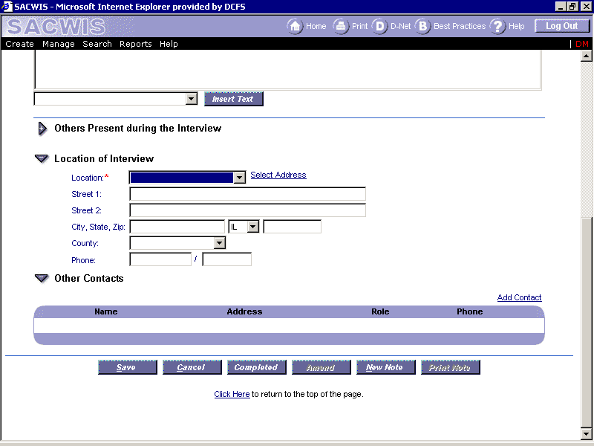
Case Maintenance | Changes to the Case Maintenance Window  On the Case Maintenance window Basic Tab:  - Added an Expando (+) below the Collaterals/Other Contacts expando Titled “Opening and Reason for Involvement History.”
Case Closure | Two new Close Reasons were added to SACWIS on the Closing History Tab on Case Maintenance Window:  - Opened in Error  - Deleted in CYCIS
Person Management | Person Management - Health Information  The Yes/No radio button is a required field if workers have recorded the child is taking psychotropic medications.
Person Management | 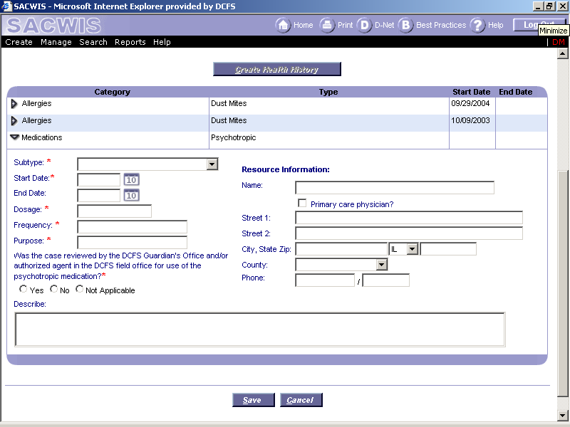

Functional Area | SACWIS Change
Risk Assessment | The following changes were made to the Risk Assessment Summary Document:  - Font Size of entire document increased to 12-point.  - “Risk Assessment Summary” label changed to all caps (RISK ASSESSMENT SUMMARY).  - Removed RSF field.  - Renamed ”Created On” field to ”Assessment Date.”  - Renamed label from ”Caretaker(s)” to ”FAMILY COMPOSITION.”  - Moved “Language” field to a new row due to the Font Size increase.  - Added a new section labeled “COMPREHENSIVE RISK ASSESSMENT REPORT.”
Risk Assessment | Workers are now able to unqualify a risk assessment if risk has been assessed and it is no longer required OR if it was created in error. However, workers are still required to submit an unqualified risk assessment for supervisor approval.
Risk Assessment | 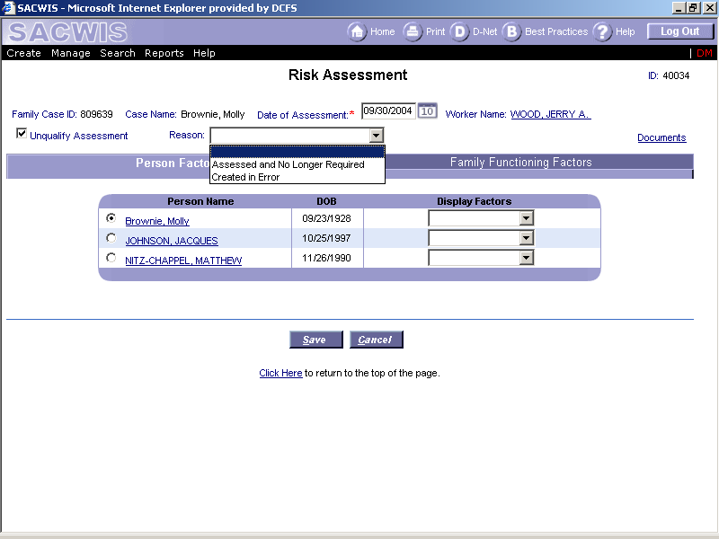
The Risk Assessment Question #41 for a caretaker has been changed to:
“Caretaker’s perception of the maltreatment or the incident(s) leading to the maltreatment exhibits a lack of empathy for the child and/or places the child at risk of harm.”
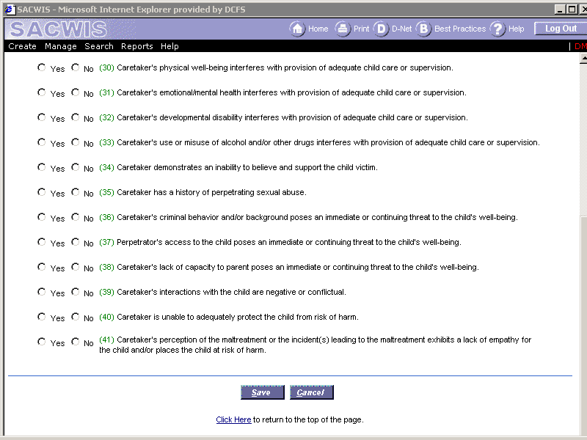
Risk Assessment

Functional Area | SACWIS Change
Integrated Assessment | The document has been changed from “Integrated Assessment” to “Social History Including Integrated Assessment.”
Integrated Assessment | The text box for the “Reason for DCFS Involvement” is a required field.
Integrated Assessment | The prompts for “Reason for DCFS Involvement” have been changed to:  - What behaviors and conditions brought this family to the attention of DCFS?  - What are the current reasons for DCFS involvement?  - Describe what circumstances and needs brought the family and child to the attention of the Department. (For CWS Intake cases)
Integrated Assessment | 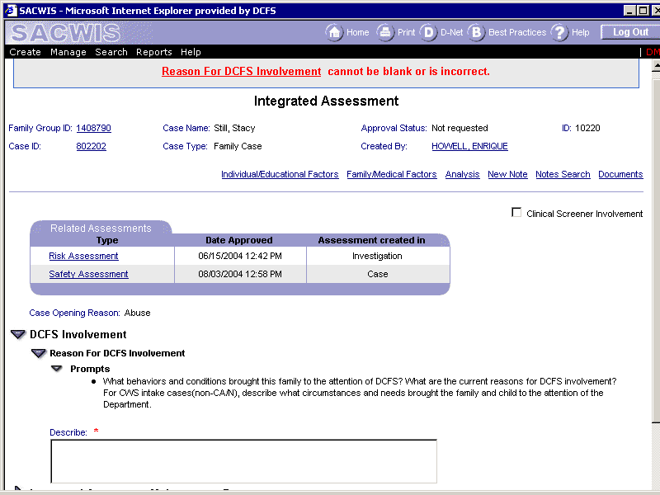
Integrated Assessment | For cases with an Approved Integrated Assessment (IA), the CYCIS Date of Temporary Custody and the CYCIS Date of Protective Custody will display for a child on the following documents:  - Person Profile Document  - Case Summary Document  - Case Closing/Transfer Document  4. Integrated Assessment Document
Integrated Assessment | Clinical Screeners can enter an initial IA report in SACWIS following collaboration with a Permanency Worker and Supervisor.  A checkbox labeled “Clinical Screener Involvement” was added to the Integrated Assessment screen.  - If the checkbox is unchecked, then the IA is titled, “Integrated Assessment – Social History.”  - If the checkbox is checked, then the IA is titled, “Integrated Assessment – Social History with Clinical Screener”
Integrated Assessment | The printed IA document will display if the IA is Initial or Subsequent Assessment.

Functional Area | SACWIS Change
Service Plan | The Intervention/Outcomes narrative fields and Evaluation fields are now frozen when the Service Plan has been approved.
Service Plan | The following changes were made to the “Compliance Questions for Children in Placement” section of the Service Plan:  - For Family Cases, all children with an open Child Case in the Family Group will be displayed. After the Service Plan is approved, this section should only display those children for whom questions were answered in this section.  - For Child Cases, only the Child Case member in this section will be displayed. After the Service Plan is approved, this section will only display the Child Case member (if questions in this section were answered for the child).
Service Plan | On the Outcome/Interventions tab of the Service Plan, workers will see a check by each outcome that has a current intervention if the ”needs to do what” field has at least 35 characters in it.
Service Plan | 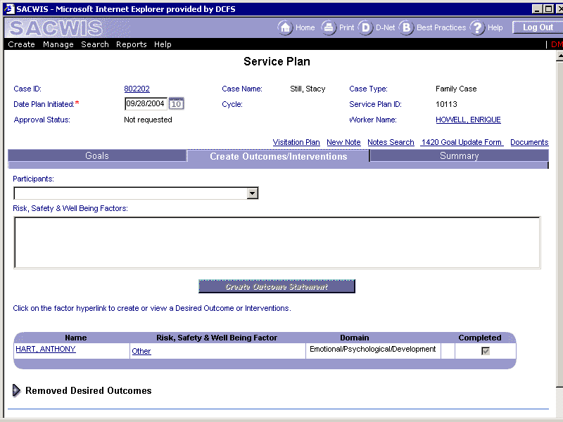
Service Plan | Changes to the Service Plan Window  On the Goals Tab:  - Removed the “Reason for Involvement” dropdown and the associated “Date Created” and “Effective Date” fields from the window.  - Added a read only field titled “Reason for Involvement.” This field will be populated from the SACWIS Reason for Involvement table.  - Added an “Effective Date” field next to the new Reason for Involvement field. The “Effective Date” is a read-only field.
Service Plan | The display of Safety Assessment Factors in the “Risk, Safety, & Well Being Factors” multi-select field on the Service Plan Outcome/Intervention Tab for a Service Plan Participant will now display the Safety Assessments Factors associated for ONLY the selected person that has Safety Factors marked “Yes” regardless of mitigating circumstance.
Service Plan | The Addendum section was renamed to “Child’s Summary.”
Service Plan | SACWIS records the worker’s name for each completed evaluation of a goal or intervention in a newly added field, “Evaluated By” on the SACWIS Service Plan Document.

Functional Area | SACWIS Change
Security | Workers with a direct assignment to a piece of work and the assigned worker’s hierarchy above will have read-only access to any piece of work with a shared member.  Supervisors will only have access to all cases in their chain of command unless they have been assigned as a designee for another supervisor.

Functional Area | SACWIS Change
Person Search | CYCIS IDs will now be returned as part of all Person Search results and be displayed right of the Primary Race column.  In addition, when two or more persons are returned from a search with the same exact ranking, the person with the CYCIS ID will be displayed before the other identically ranked candidates without CYCIS IDs.

