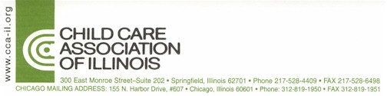

MEDIA ADVISORY Contact:
19 May 2005 David Ormsby, 773-583-0963

Press Conference:

Lawmakers, Foster Parents Urge Governor, Legislative Leaders to Hike Foster Kid Expenses by $4 Million

“Caring for Foster Kids of 2005 with Dollars of 1999”

(Springfield)—State legislators, foster parents, and the state’s leading child welfare association will call on Governor Rod Blagojevich and General Assembly legislative leaders to provide a $4 million budget increase for foster children expenses at a press conference on Thursday, May 19 at 10:00 a.m.

A bi-partisan group of suburban lawmakers—State Senator Jeffrey Schoenberg (D-Evanston) and State Representatives Rosemary Mulligan (R-Des Plaines), Beth Coulson (R-Glenview) and Lou Lang (D-Skokie)—will join local foster parents and the Child Care Association of Illinois President, Margaret Berglind at the State House Blue Room.

The state has failed to provide a foster child expense increase for a fifth year in a row.

-30-

